Project 5- Progress Report

Colorado River Basin Model Economic Output of Lower Basin Addition

Brett Safely- A0227503

Matthew Fugal- A02298739

Dr. David E. Rosenburg

CEE 6410- Systems Analysis

Oct 21, 2024

<https://github.com/fugalmatt/CEE-6410-Fugal>

**Abstract**

This report details the group’s progress in expanding the “ColoradoRiverBasinAccountsAdaptive” model described in “Lessons Learned from Immersive Online Collaborative Modeling to Discuss More Reservoir Operations (Rosenberg 2024). This report first describes the problem that the model and model expansions seek to address. Next, the report describes the model formulation for the problem. It will then describe the additions made to this project over previous work. The report will then detail the major findings of the model to date. After this, it will discuss the proposed next steps for the model progression. Finally, this report will cover the expected challenges in completing the model additions.

**Problem**

Water models serve various purposes for stakeholders, helping them understand the effects of resource allocation and management decisions and to visualize conflicting objectives. These models are especially valuable in addressing societal challenges associated with water use. According to the ASCE Code of Ethics, civil engineers developing such models must consider society’s current and anticipated needs while striving to enhance the quality of life for humanity. This project addresses these principles by focusing on integrating economic output into water models, highlighting the monetary benefits of water use.

Building on the existing immersive online model developed by David Rosenberg (Rosenberg 2024), this project incorporates economic factors that reflect the value of water in agricultural and urban contexts. The model accounts for revenue generated per acre-foot of water allocated to agriculture and the economic output of urban users, represented by nonfarm labor wages and the municipal water usage associated with those laborers. This contribution aims to support more informed decision-making by combining economic metrics with existing water modeling tools. The following sections detail the project’s progress, including the model formulation for integrating economic factors, the contributions of the authors, the major findings to date, and the next steps and anticipated challenges with completing the project. Included is an appendix containing an annotated bibliography for this project.

**Model Formulation**

1. Model Choices:
   1. The model will introduce two new choices based on water allotted to each entity. First, users will determine a percentage of their allocated water for agricultural use and a percentage of their allocated water for urban use. Based on whether entities select to use water for agricultural use, they may select up to three crops best suited to grow in their areas. Each crop will be assigned a percentage of agricultural land used in the area, with no more than 40% of the total available land allotted to high-value crops, as indicated by the dropdown menu.
2. Computations
   1. Based on the spreadsheet sample section below, new calculations will be the agricultural benefit and urban benefit using the following equations:
$$Z_{urban}=\sum{C_{urban,state}*X_{urban,state}}$$

$$Z_{agg}=\sum{C_{agg,state}*X_{agg,state}}$$

3. State Variables:
   1. The new computations assume available water is a state variable. This state variable is calculated using the existing immersive model based on user selections.
4. Outputs:
   1. The final outputs of this model will be the benefit generated from crop growth and urban productivity expressed in dollars.
5. Feedback to next step:
   1. There is no feedback to the next timestep.
6. Model Overview (Spreadsheet Layout)

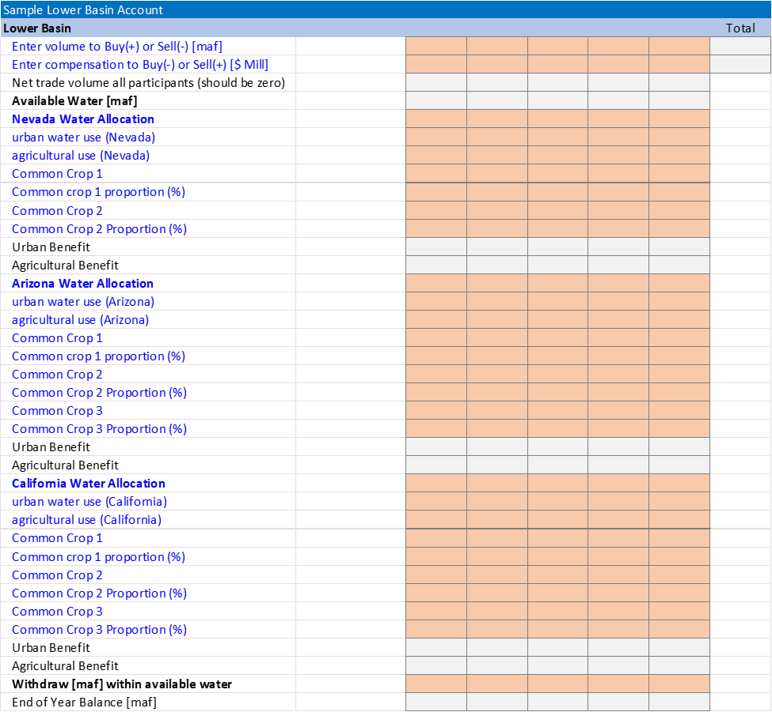**Contributions over Previous Work**

This project includes the addition of state allocation for the lower basin region of the Colorado River Basin. Arizona, California, and Nevada sections have been added so that water allocated to the lower basin can be further allocated to each state. Each state user of the model will be able to allocate water to either urban or agricultural water use. The spreadsheet has also been updated to include the ability to select the two to three most common crops planted for each year for each state and the proportions of agricultural water allocated to each crop.

The spreadsheet includes data from the USDA listing the common crops for each state, their yield, and their unit price. Each state has a list of common crops that will be selectable in the spreadsheet; Arizona has 14 common crops added to the spreadsheet, including hay, corn, and cotton; California has 50 common crops listed by the USDA, including almonds, hay, and grapes; Nevada has two common crops listed by the USDA: hay and corn. Data from the USDA included in the spreadsheet also consists of the average yield of each crop per state, typically in terms of weight per acre of cultivated land. Data about the unit price for each crop in each state has also been added; combined with the yield of each crop, a profit per acre is calculated for each crop.

**Major Findings to Date**

Chapter 5 of “Determining the Economic Value of Water” by Robert A. Young outlines the economic valuation of water in agriculture, emphasizing irrigation. The methods detailed in Sections 5.4 through 5.7 cover both inductive and deductive approaches, with considerations for their practicality and relevance to specific valuation models.

1. Inductive Methods for Agricultural Water Valuation
   1. Water Rights Market Evaluation
      1. This method evaluates the buying and selling power of water, so it is not applicable to this model. Our focus is on the productive value of water in irrigation, not on market transactions, which are addressed in the crop in the immersive model.
   2. Land Value Method
      1. This method calculates the economic impact of ceasing irrigation, based on land-use changes. However, given the assumption that land use does not permanently change (irrigation may stop but can be reinstated), this method is also excluded.
   3. Hedonistic Property Value
      1. This technique assesses water’s value through property price changes but is omitted here, as it does not meet the needs of the model.
2. Deductive Methods for Agricultural Water Valuation
   1. Residual Method
      1. The most frequently used approach in irrigation valuation, the residual method, calculates water's contribution to profit by focusing on the value of outputs (crop production). This aligns with the model's objective of evaluating profit while accounting for both costs and returns.
      2. This method avoids bias, as pricing is based on established data.
      3. It effectively distinguishes between high-value crops (e.g., vegetables, fruits, vines) and basic crops (e.g., rice, wheat, corn), reflecting the diversity of agricultural outputs.
      4. A notable observation is that over 60% of irrigated land in California is still dedicated to basic crops, so the model will maintain this as a recommended comment in crop selection as to not disrupt food production requirements for the Lower Basin
   2. Alternative Cost Method
      1. This method, which evaluates the costs of switching from surface water to groundwater, is excluded from the model due to its lack of relevance to the specific focus on surface irrigation.

Based on the various methods presented by Young, we find the Residual Method to evaluate agricultural water value most suitable for the purposes of the model.

Chapter 7 examines the valuation of water in municipal applications, focusing on balancing affordability, efficiency, and sustainability. Detailed below are the sections of the chapter relevant to the project.

1. Water Valuation for Municipal Water Demand
   1. Components:
      1. Water demand is divided into household consumption, public services, and commercial uses. Demand for essential uses (e.g., drinking, sanitation) is less elastic, while discretionary uses (e.g., lawn irrigation) are more sensitive to price changes.
   2. Elasticity:
      1. Municipal water demand is generally price inelastic, but higher elasticity for non-essential uses provides an opportunity for conservation-focused pricing strategies.
   3. Pricing Structures
      1. Uniform Pricing: A flat rate per unit. Simple but does not promote conservation.
      2. Increasing Block Rates: Prices increase with usage, encouraging efficiency among high-volume users.
      3. Seasonal Pricing: Higher rates during peak demand (e.g., summer) reflect increased supply costs.
   4. Cost Recovery and Equity
      1. Infrastructure Sustainability:
         1. Cost-recovery pricing is essential for maintaining municipal water systems. Under-pricing water leads to underinvestment in infrastructure, resulting in long-term inefficiencies.
      2. Equity Considerations:
         1. Pricing must ensure water remains accessible for all socio-economic groups. Inadequate access to water has direct public health implications, indicating the need for policy design.
      3. Conservation Policies
         1. Municipal water conservation efforts are essential for long-term sustainability. The chapter identifies several strategies:
         2. Incentives: Rebates for water-efficient appliances.
         3. Public Education: Awareness campaigns on water-saving practices.
         4. Seasonal Restrictions: Limits on non-essential water uses like outdoor irrigation.
         5. Technology: Advanced metering to monitor usage and identify inefficiencies.

The findings from Chapter 7 focus on pricing water effectively for municipal water supply managers to best serve their jurisdiction. As such, little is learned on how to monetarily quantify the value created by urban water users. Thus, we still maintain the position of using median nonfarm salary multiplied by nonfarm population to quantify benefit generated from urban water use.

**Next Steps**

The next steps for this project are relatively straightforward. First, we need to ensure our water requirement meets reasonable assumptions based on USDA data. Second, we will incorporate this data into the spreadsheet model, correcting all reference errors that have shown up. Finally, we will write our final report for the project.

**Anticipated Challenges**

Anticipated challenges include troubleshooting the references on the spreadsheet. Currently, file loss and corruption have caused us to recreate work that has been lost. Excel has also shown signs of struggling on the hardware available to the team; this could lead to potential crashes in the future, corrupting work that had been done.

**Appendix A: Annotated Bibliography**

Title: Evaluating the economic impact of water scarcity in a changing world

Authors: Flannery Dolan, Jonathan Lamontagne, Robert Link, Mohamad Hejazi, Patrick Reed, Jae Edmonds

DOI: [10.1038/s41467-021-22194-0](https://doi.org/10.1038/s41467-021-22194-0)

Key Points:

* Water scarcity is influenced by climate change, basin-level water resources, and adaptive capacities of managed systems.
* The study links a global human-Earth system model, a global hydrologic model, and a metric for economic surplus loss due to resource shortages.
* Major hydrologic basins can experience significant economic impacts due to global trade dynamics and market adaptations.
* Market adaptation can magnify economic uncertainty relative to hydrologic uncertainty.
* The study emphasizes the need to consider multi-sector, multi-scale economic teleconnections in addressing water scarcity.

Title: Economic Analysis of Sustainable Water Use: A Review of Worldwide Research

Authors: Luis Jesús Belmonte-Ureña, Encarnacion Pajares, Juan F. Velasco-Muñoz, José A. Aznar-Sánchez, Isabel M. Román-Sánchez

DOI: 10.1016/j.jclepro.2018.07.066

Key Points:

* The study reviews 25 years of international research on sustainable water use in agriculture.
* A bibliometric analysis was conducted, sampling 2084 articles.
* Results indicate exponential growth in the number of articles published per year.
* Environmental Science and Agricultural and Biological Sciences are the main categories of research.
* China, the U.S., Australia, India, and Germany are the leading countries in this field.
* The study emphasizes the importance of sustainable water management practices to address water scarcity.

Title: Urban and Agricultural Water Use in California, 1960–2015

Authors: Heather Cooley

DOI Number: Not applicable

Key Points:

* The study covers water use trends from 1960 to 2015, focusing on both urban and agricultural sectors.
* Data from the California Department of Water Resources (DWR) was used for analysis.
* Total water use in California has stabilized since the 1980s.
* The report discusses the factors influencing these trends and their implications for future water management.
* Report can help assign economic values to various activities associated with water use in California. Results may be generalized other western states?

Title: Estimates of Water Use and Trends in the Colorado River Basin, Southwestern United States, 1985–2010

Authors: Molly A. Maupin, Tamara Ivahnenko, and Breton Bruce (2018)

DOI: <https://doi.org/10.3133/sir20185049>.

Key Points:

This report comprehensively describes the estimations for all water use from the Colorado River Basin between 1985 and 2010 and the estimation methods used by the USGS. Total water usage averaged 17 million acre-ft per year, 78% of which was surface water usage, and was evenly split between upper and lower basin water use. Irrigation was the largest water user, accounting for 83-90% of the usage; this was followed by public-supply usage accounting for 6-13%. Hydroelectric usage was not accounted for, as any losses were attributed to reservoir evaporation, which the USGS does not report. The water usage of all the states in the basin was tracked, with water usage being greatest in Arizona and Colorado and smallest in California, Nevada, and New Mexico. Data was collected from various sources, with federal and state agencies being the biggest contributors; the compilation method for the data varied by state.

Title: Comparison of U.S. Geological Survey and Bureau of Reclamation Water-Use Reporting in the Colorado River Basin

Authors: Brenton W. Bruce, James R. Prairie, et al. (2019)

Doi: <https://doi.org/10.3133/sir20185021>.

Key Points:

This report summarizes the methods used by the USGS and Bureau of Reclamation in estimating water usage in the Colorado River Basin and how future cooperation may lead to improved estimations. The two agencies differ on the categorization of water use. Both agencies use similar categorizations for livestock, thermoelectric cooling, and mining water usage, but they differ in defining irrigation, municipal, and industrial water usage, and interbasin water transfers. The agencies also differ on methods for estimating the upper and lower basin water use; the USGS uses similar methods in the upper and lower basin as they use in the rest of the US, while the Bureau of Reclamation uses estimations of diversions in the lower basin and models for estimating water usage in the upper basin. Additionally, the USGS mainly focuses on the volume of water withdrawn by each of its 12 defined sectors. In contrast, the Bureau of Reclamation focuses on how each of its ten defined sectors uses water. The USGS and Bureau of Reclamation use various estimation methods, with each agency having methods that are better suited for some water use estimations; this report suggests that combining methods used and working together to create new and improved methods will benefit both agencies in estimating water usage in the basin.

Title: The Colorado River water crisis: Its origin and the future

Authors: John C. Shmidt, Charles B. Yackulic and Eric Kuhn (2023)

Doi: <https://doi.org/10.1002/wat2.1672>.

Key Points:

This report covers the severity of the water shortage in the Colorado River Basin and potential solutions to the issue. Between 2000 and 2020, water usage in the basin was approximately 1.5 million acre-ft per year, more than inflows on average, leading to a 33.5 million acre-ft decline in volume in Lake Mead and Lake Powell between 2000 and 2023. This is primarily due to the decrease in inflow into the basin, with the average annual inflow between 2000 and 2023 being 13% less than between 1930 and 1999. The yearly inflow is expected to continue to decline because of climate change, with an estimated 1-3 million acre-ft per year decline by 2050. To accommodate the decrease in inflow, water usage would need to be reduced by 1.5 million acre-ft per year to stop the depletion of Lake Mead and Lake Powell, with a roughly 2.5 million acre-ft per year decrease required to refill the reservoirs. Opportunities to reduce water usage are available for mid-size urban areas, specifically for populations between 100,000 and 1,000,000 people; reduction in agricultural use is also possible, with the lower basin proposing to subsidize farmers by $1 billion. Combining storage into solely one of the two reservoirs (Lake Mead or Lake Powell) should also be considered to aid in water management. This report suggests that part of the solution will need to be reworking the water law to be a proportional distribution of water to account for further projected decreases in inflow.

Title: Optimal Water Allocation under Deficit Irrigation in the Context of Colorado Water Law

Authors: Manijeh Mahmoudzadeh Varzi, Thomas J. Trout, et al. (2019)

DOI: 10.1061/(ASCE)IR.1943-4774.0001374.

Key Points:

This report describes a model to optimize water usage for a farm with a single crop based on water leasing and deficit irrigation practices. A farm in the South Platte Basin was assessed as a case study for using this model and for the effectiveness of deficit irrigation. The case study found that for the water leasing prices for that area and time, the optimal water use was to use deficit irrigation or to lease all water; this was due to high water leasing prices. The case study looked at sunflower and maize crops and found that deficit irrigation was viable for maize for a broader range of leasing prices than for sunflowers because the sunflowers' water usage is less “concave,” this can be more generally applied that crops with more “concave” water usage are more viable for deficit irrigation. This model was found to be too imprecise and challenging for individual farmers, but it is still a viable method for defining water leasing prices.

Title: Lessons from Immersive Online Collaborative Modeling to Discuss More Adaptive Reservoir Operations

Author: David E. Rosenberg (2024)

DOI: <https://doi.org/10.1061/JWRMD5.WRENG-5893>

Key Points:

This document provides description of the existing model which we are supplementing with this project.